Name-Ujjawal Mandhani
Batch-F6
Enroll No.-9918103237
OSS Lab-4

Question 1:

import numpy as np
a = np.array([10, 10, 20, 10, 20, 20, 20, 30, 30, 50, 40, 40])
print("Original array:")
print(a)
unique_elements, counts_elements = np.unique(a, return_counts=True)
print("Frequency of unique values of the said array:")
print(np.asarray((unique_elements, counts_elements)))

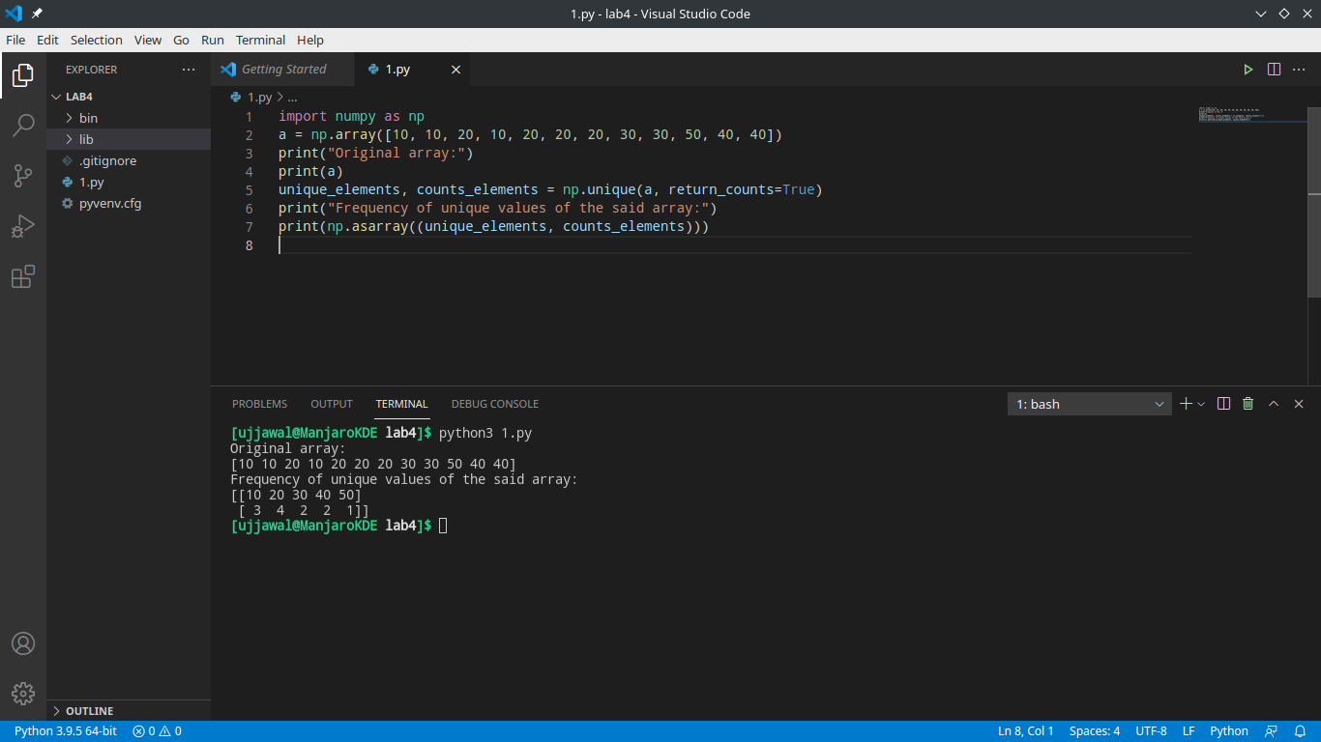
Question2:

def segregate0and1(arr, size):
left, right = 0, size-1
while left < right:
while arr[left] == 0 and left < right:
left += 1
while arr[right] == 1 and left < right:
right -= 1
if left < right:
arr[left] = 0
arr[right] = 1
left += 1
right -= 1

return arr

arr = [0, 1, 0, 1, 1, 1]
arr_size = len(arr)
print("Array after segregation")
print(segregate0and1(arr, arr_size))

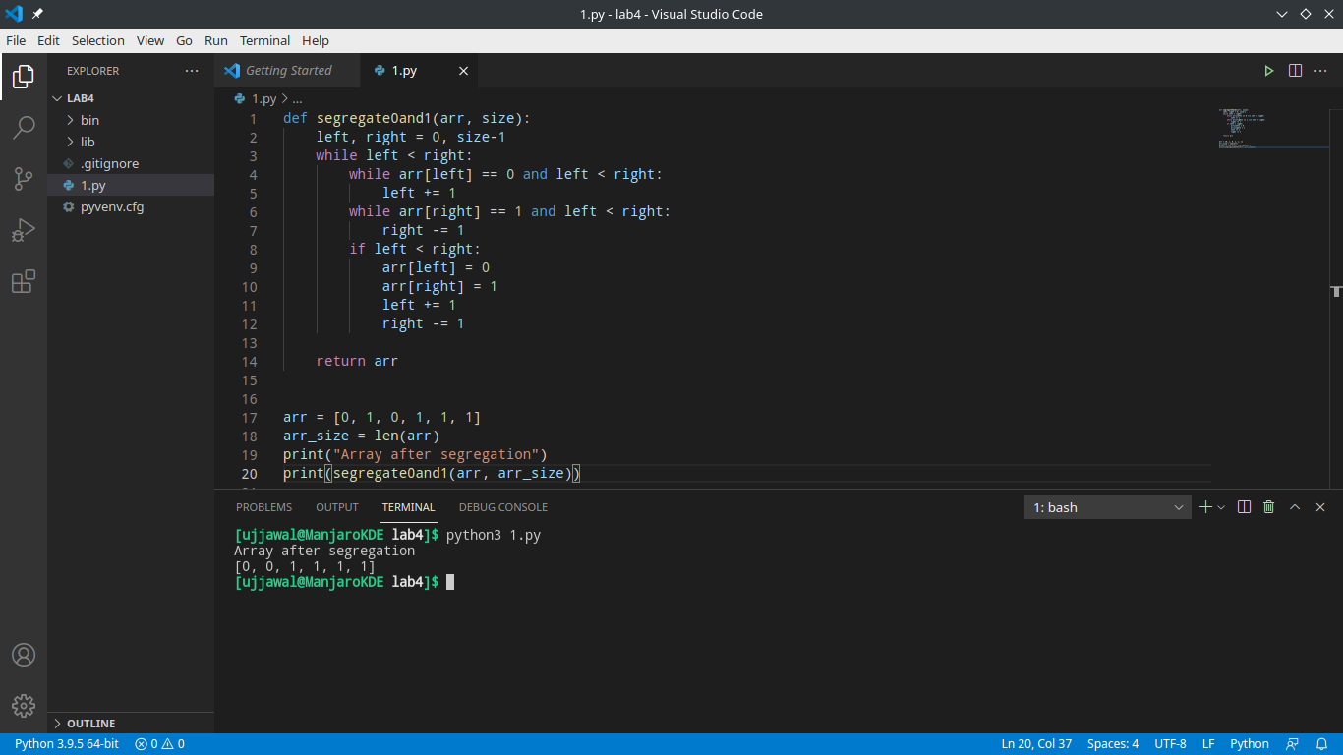
Question 3:

def remove_char(str, n):
first_part = str[:n]
last_part = str[n+1:]
return first_part + last_part

print(remove_char("Ujjawal", 0))
print(remove_char("Mandhani", 1))
print(remove_char("Python", 5))

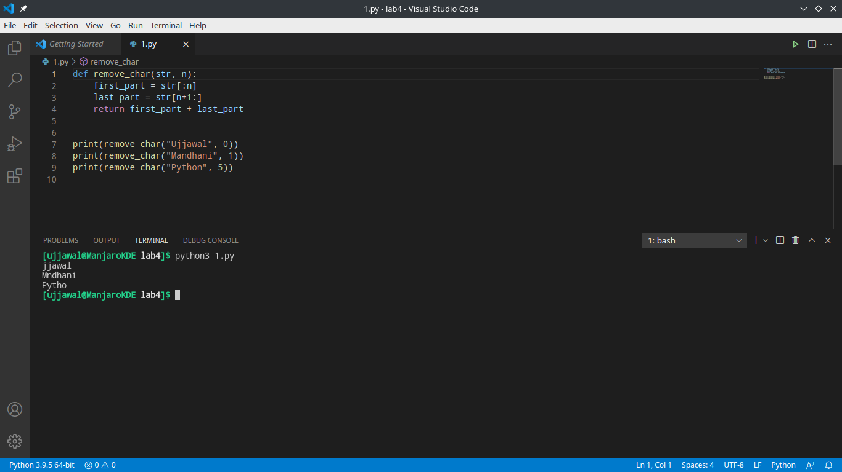
Question 4:

import numpy as np
array1 = np.array([0, 10, 20, 40, 60])
print("Array1: ", array1)
array2 = [0, 40]
print("Array2: ", array2)
print("Compare each element of array1 and array2")
print(np.in1d(array1, array2))

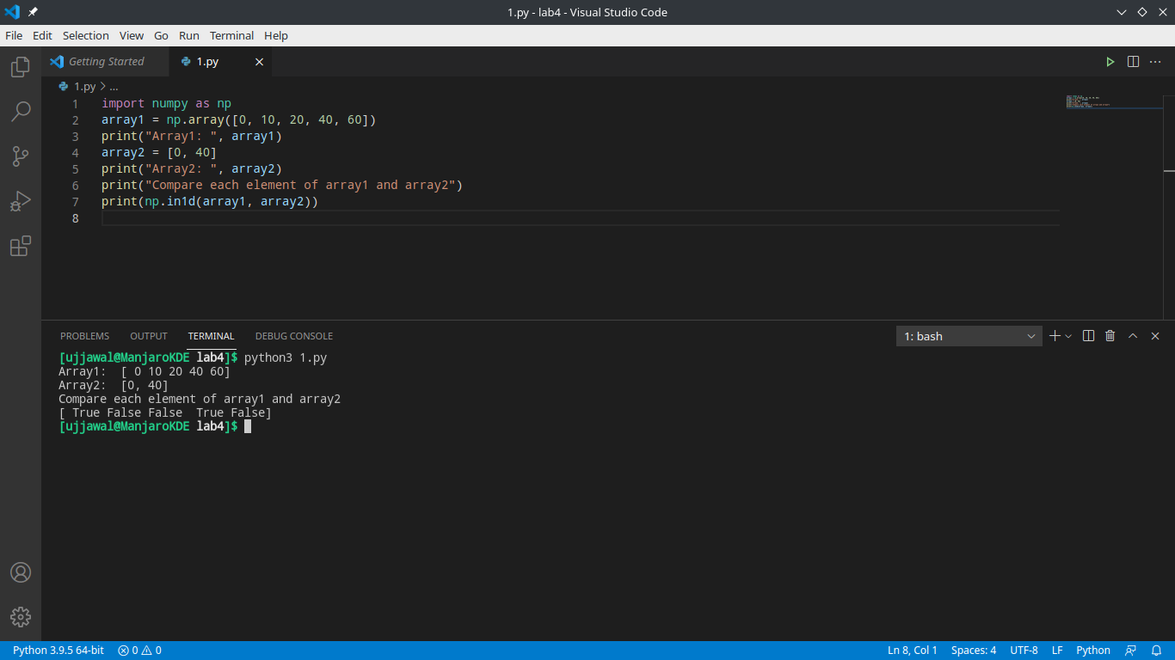
Question 5:
import numpy as np
array1 = np.array([0, 10, 20, 40, 60, 80])
print("Array1: ", array1)
array2 = np.array([10, 30, 40, 50, 70])
print("Array2: ", array2)
print("Unique values that are in only one (not both) of the input arrays: ")
print(np.setxor1d(array1, array2))

